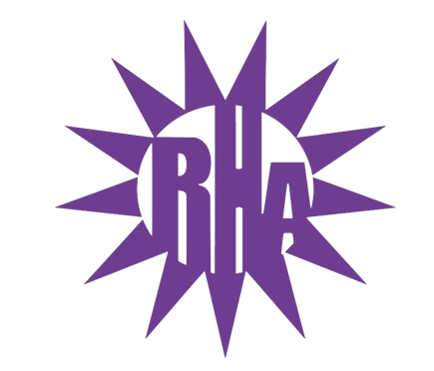
Residence Hall Association
General Assembly Meeting
September 15, 2021
UC 259
- Call to Order
- Welcome/RHA Introduction
- Icebreaker
  - Bounce
  - I’m Glad You’re Here
  - Activity
- Executive Board Introductions
- Advisor Introductions
- Roll Call/General Assembly Introductions
- New Business
  - Parliamentary Procedure
  - Agenda
  - General Assembly (GA) Role
  - UWW TV Recording
  - Assembly Books
- RHA Traditions
  - General
    - Snaps
    - You Rock/You Rule
    - OTMs
    - Golden Artichoke
  - Programs
    - HALLoween
    - Whitewater’s Got Talent
    - Superbowl
    - Lil Sibs
    - Brewer’s Game
    - Programming Committee
- Final Thoughts
- Adjournment

Next Meeting: September 22, 2021
Theme: Warhawk Pride

