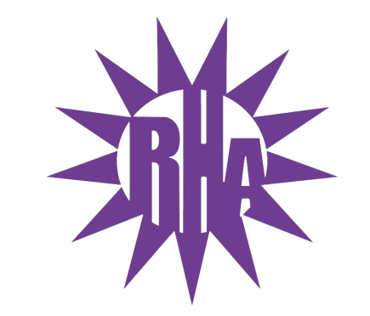
Residence Hall Association
General Assembly Meeting
September 22, 2021
UC 259
- Call to Order
- Roll Call/Icebreaker
  - I’m Glad You’re Here
- Approval of the Minutes
  - May 3, 2021
- LIT Reports
- Executive Reports
- Advisor Reports
- Old Business
  - Swear In President
  - Swear In Executive Assistant
  - Swear in National Communications Coordinator
  - Swear In Co-Programing Coordinators
  - Swear In Publicity and Recognition Coordinator
- Guest Speakers
- New Business
- UC Advisory Board Representative (BP)
- SUFAC Representative (MG)
- Update on Programs
  - Welcome Back Throwback – Video and Attendance
- Committee Reports
- WSG Report
- NRHH Report
- Jitters Report
- RA Report
- Final Thoughts
  - Snaps
  - U Rock U Rule
  - Golden Artichoke
- Adjournment

Next Meeting: September 29, 2021
Hyland 2203 Baker/Tilly Lecture Hall
Theme: Tacky Shirts

