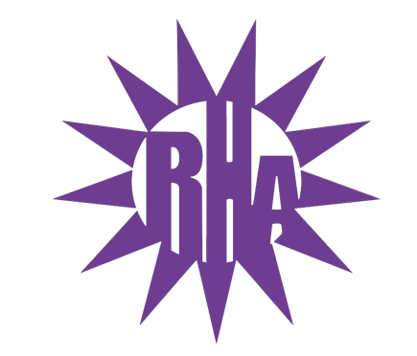
Residence Hall Association
General Assembly Meeting
September 29, 2021
Hyland 2203
- Call to Order
- Roll Call/Icebreaker
  - I’m Glad You’re Here
- Approval of the Minutes
  - May 3, 2021
  - September 22, 2021
- LIT Reports
- Executive Reports
- Advisor Reports
- Old Business
  - Swear In Vice President
- Guest Speakers
  - Dan and Alison – UWW Police Department
- Update on Programs
- New Business
  - Budget Presentation
  - OTM Presentation
  - Nia Mooney – Funding Request
  - Complex Selection and Make-Up For Next Year
- WSG Report
- NRHH Report
- Jitters Report
- Committee Reports
- RA Report
- Final Thoughts
  - Snaps
  - U Rock U Rule
  - Golden Artichoke
- Adjournment

Next Meeting: October 6, 2021
Theme: Neon

