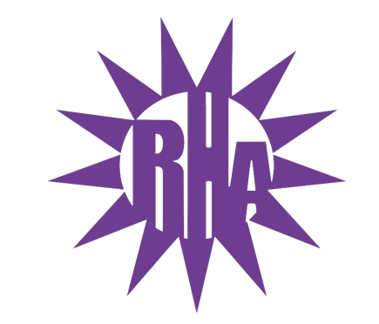
Residence Hall Association
General Assembly Meeting
October 13, 2021
UC 295
- Call to Order
- Roll Call/Icebreaker
  - I’m Glad You’re Here
- Approval of the Minutes
  - October 8, 2021
- LIT Reports
- Executive Reports
- Advisor Reports
- Old Business
- Guest Speakers
  - Dining
- New Business
  - Funding Request: Wells Prom Coordinating Team – Genna
- Committee Reports
  - Internal: OTM Committee
- WSG Report
- NRHH Report
- Jitters Report
- RA Report
- Final Thoughts
  - Snaps
  - U Rock U Rule
  - Golden Artichoke
- Adjournment

Next Meeting: October 20, 2021
Theme: Flannel

