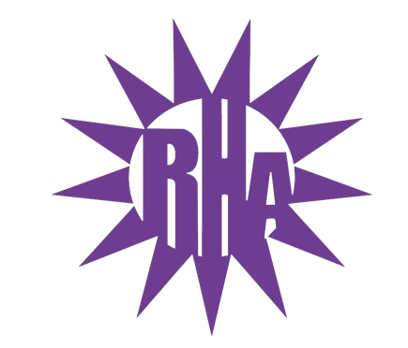
Residence Hall Association
General Assembly Meeting
October 20, 2021
UC 295
- Call to Order
- Roll Call/Icebreaker
  - Wells Hall Highlight
- Approval of the Minutes
  - October 13, 2021
- LIT Reports
- Executive Reports
- Advisor Reports
- Old Business
- Guest Speakers
  - Julie Minikel-Lacocque – NCBI
  - WSG
  - Terry
- New Business
  - Homecoming Participation/Interest Form
- Committee Reports
  - External Committee – SUFAC Representative
  - External Committee – Dining Feedback
- WSG Report
- NRHH Report
- Jitters Report
- RA Report
- Final Thoughts
  - Snaps
  - U Rock U Rule
  - Golden Artichoke
- Adjournment

Next Meeting: October 27, 2021
Theme: Halloween Costume

