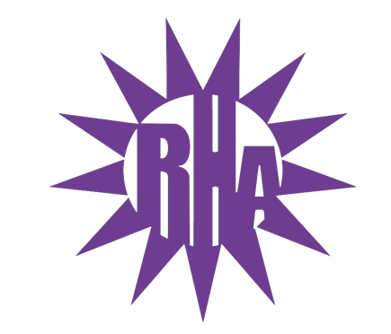
Residence Hall Association
General Assembly Meeting
October 27, 2021
UC 295
- Call to Order
- Roll Call/Icebreaker
  - Ma’iingan Hall Highlight
- Approval of the Minutes
  - October 20, 2021
- LIT Reports
- Executive Reports
- Advisor Reports
- Old Business
- Guest Speakers
  - RA Applications – Ever Aroca
- New Business
  - Student Check In
- Committee Reports
  - External Committee
    - SUFAC Representative
    - Dining Committee Update
- WSG Report
- NRHH Report
- Jitters Report
- RA Report
- Final Thoughts
  - Snaps
  - U Rock U Rule
- Adjournment

Next Meeting: November 3, 2021
Theme: Animal Print

