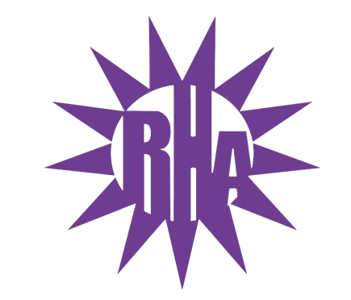
Residence Hall Association
General Assembly Meeting
October 6, 2021
UC 295
- Call to Order
- Roll Call/Icebreaker
  - Wellers/Knilans Hall Highlights
- Approval of the Minutes
  - September 29, 2021
- LIT Reports
- Executive Reports
- Advisor Reports
- Old Business
  - Dining Committee Representative
- Guest Speakers
- Update on Programs
- New Business
  - GLACURH Presentation
  - Food Drive Proposal
- Committee Reports
- WSG Report
- NRHH Report
- Jitters Report
- RA Report
- Final Thoughts
  - Snaps
  - U Rock U Rule
  - Golden Artichoke
- Adjournment

Next Meeting: October 13, 2021
Theme: Tie Dye

