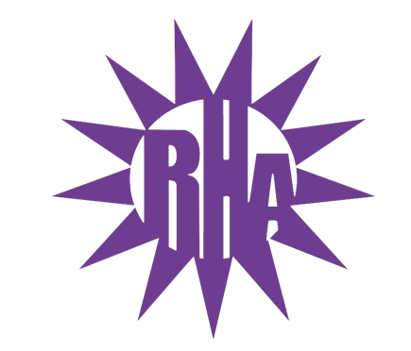
Residence Hall Association
General Assembly Meeting
November 17, 2021
UC 259
- Call to Order
- Roll Call/Icebreaker
  - Benson/Cambridge Hall Highlight
- Approval of the Minutes
  - November 10, 2021
- LIT Reports
- Executive Reports
- Advisor Reports
- Old Business
- Guest Speakers
- New Business
  - ISA Funding Request
  - Greek Residence Floor
  - Candy Cane Sales
- Committee Reports
- External Committee – Dining Committee
- WSG Report
- NRHH Report
- Jitters Report
- RA Report
- Final Thoughts
  - Snaps
  - U Rock U Rule
  - Golden Artichoke
- Adjournment

Next Meeting: December 1, 2021
Theme: Sparkle

