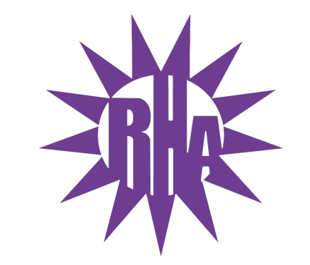
Residence Hall Association
General Assembly Meeting
December 1, 2021
UC 259
- Call to Order
- Roll Call/Icebreaker
  - Arey/Fricker Hall Highlight
- Approval of the Minutes
  - November 17, 2021
- LIT Reports
- Executive Reports
- Advisor Reports
- Old Business
  - ISA Funding Request
- Guest Speakers
  - Terry
- New Business
- Committee Reports
- WSG Report
- NRHH Report
- Jitters Report
- RA Report
- Final Thoughts
  - Snaps
  - U Rock U Rule
  - Golden Artichoke
- Adjournment

Next Meeting: December 8, 2021
Theme: Ugly Sweaters

