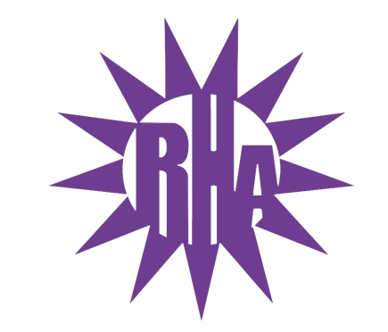
Residence Hall Association
General Assembly Meeting
November 10, 2021
UC 259
- Call to Order
- Roll Call/Icebreaker
  - Lee-Bigelow Hall Highlight
- Approval of the Minutes
  - November 3, 2021
- LIT Reports
- Executive Reports
- Advisor Reports
- Old Business
- Guest Speakers
  - UHCS
- New Business
- Committee Reports
- OTM Committee
- WSG Report
- NRHH Report
- Jitters Report
- RA Report
- Final Thoughts
  - Snaps
  - U Rock U Rule
  - Golden Artichoke
- Adjournment

Next Meeting: November 17, 2021
Theme: Crazy Hats

