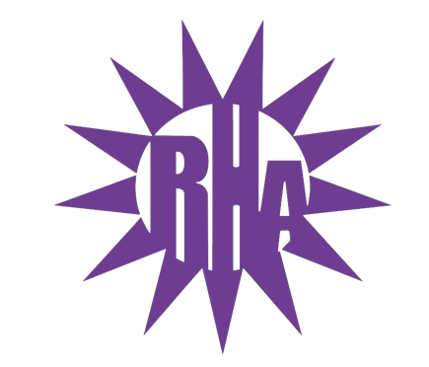
Residence Hall Association
General Assembly Meeting
February 2, 2022
UC 259

- Call to Order
- Roll Call/Icebreaker
- Approval of the Minutes
  - December 01, 2021
- LIT Reports
- Executive Reports
- Advisor Reports
- Old Business
- Guest Speakers
  - Ever Aroca – RA Recruitment
- New Business
  - Parli Pro Video
  - Parli Pro Kahoot
  - RHA Crush Can Sale
- Committee Reports
- WSG Report
- NRHH Report
- Jitters Report
- RA Report
- Final Thoughts
  - Snaps
  - U Rock U Rule
  - Golden Artichoke
- Adjournment

Next Meeting: February 9, 2022
Theme: Wear All Pink

