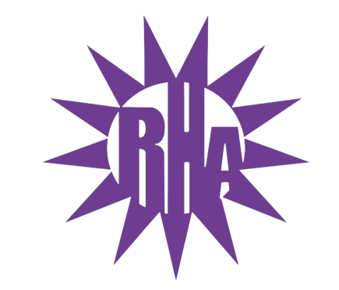
Residence Hall Association
General Assembly Meeting
February 9, 2022
UC 259

- Call to Order
- Roll Call/Icebreaker
- Approval of the Minutes
  - February 2nd, 2022
- LIT Reports
- Executive Reports
- Advisor Reports
- Old Business
  - Approval of the minutes from December 1st, 2021
- Guest Speakers
  - Peer Mentors
  - Winther Counseling Services
- New Business
- Committee Reports
- WSG Report
- NRHH Report
- Jitters Report
- RA Report
- Final Thoughts
  - Snaps
  - U Rock U Rule
  - Golden Artichoke
- Adjournment

Next Meeting: February 16th, 2022
Hyland 2101 Anchor Bank Lecture Hall
Theme: Tie Dye

