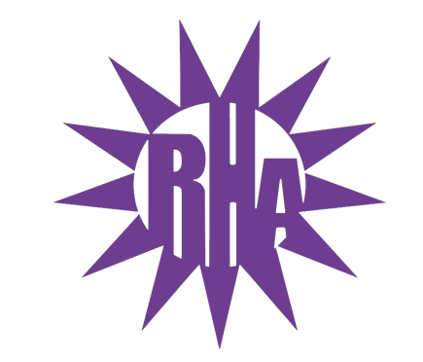
Residence Hall Association
General Assembly Meeting
October 5, 2022
UC 275
- Call to Order
  - 7:09
- Roll Call/Icebreaker
  - Notecard Fun Facts
- Approval of Minutes
  - September 28, 2022

- LIT Reports
  - https://tinyurl.com/RHAreport
Arey/Fricker- not in attendance
Benson/Clem- door decorating competition with winner announced on October 21^{st.} Holiday/Costume party same day in the basement.
Lee/Bigelow- September 29th event -Switching it up with Lit. They played Jackbox games and Mario cart. About 20 people attended. Upcoming events include October 13th- 7-9pm “Pie an RA” $2 each and donation go to Warhawk Pantry
Wells- Next event is an ice cream/ hot cocoa social next Thursday in jitters, and they are working on events for month
Wellers/Knilans – LIT discussed monthly meeting and goals for success, and they next event is an ADHD awareness event on October 13th 6-7pm. They are holding an October 27th Halloween party
Tutt/Fischer- LIT talked about future programs, including Halloween program on October 17th.
Pulliam- Last meeting included assigning roles and brainstorming program ideas
Ma’iingan- Last meeting discussed leadership and talked about planning programs and positions
- Executive Reports
- Advisor Reports
  - Kayla- nothing to share
  - Travis- Gave thanks to everyone for attending, and mentioned RHA advisors had a meeting on 10/5
- Old Business
- New Business
  - Executive Board Presentations
    - Executive Assistant
    - National Communications Coordinator
    - Programmer
      - Orin Smith
    - Publicity and Recognition Director
- Committee Report
  - UW-W Homecoming Committee
    - Report from Delegates of October 3rd Meeting
      - Banner Competition
      - Talent Show Auditions: Sunday, October 23rd at 7pm in UC Hamilton Room
      - Study Night: Monday, October 24th at 7pm in UC Hamilton Room
      - Trivia Night: Tuesday, October 25th at 7pm in UC Hamilton Room
      - Bingo Night: Wednesday, October 26th at 7pm in UC Hamilton Room
      - Talent Show: Thursday, October 27th at 7pm in Young Auditorium
      - Indoor Games: Friday, October 28th at 12pm in Kachel Fieldhouse
      - Parade: Saturday, October 29th at 10am on Main Street
    - Future Informational Meeting Dates
      - Monday, October 10th at 9pm in Summers Auditorium
      - Monday, October 17th at 9pm in Summers Auditorium
- Program Updates
  - Boxes & Walls in Esker Hall
    - Sunday, October 16th from 2-5pm
    - Monday, October 17th through Thursday, October 20th from 6-10pm
    - Volunteers are needed!!
  - Whitewater’s Got Talent – November 29th
- WSG Report
  - Is starting with segregating fees processing
  - Got approval for posters in halls
- NRHH Report
  - Hosted 1st official meeting, updated e-board, discussed ice breakers, and is currently taking over OTMs
- Jitters Report
  - Events update included: Hoedown this Friday, October 13th Cereal killer night, Jitters Board met with Jitters hall representatives on 5th, and they are hosting karaoke night every Monday night
- RA Report
  - Micheal – Hosted Bagel Olympics
  - Dalon- Residents decorated his floor
  - Brenna- Reminded assembly about LIT Logo competition
  - Bobbie- floor has brought community to new high (midnight talks, etc.)
- Final Thoughts
  - Snaps
  - U Rock U Rule
  - Golden Artichoke
- Adjournment:
Motioned made by Ma’iingan
Seconded by Bigelow

Next Meeting: October 12, 2022 in UC 275
Theme: Halloween Colors (Spooky Vibes)

