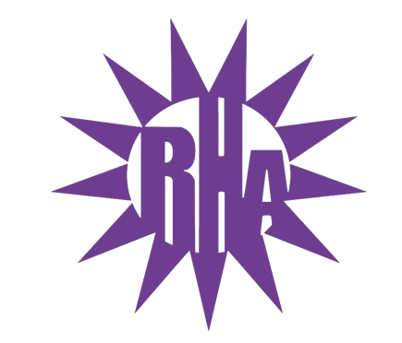
Residence Hall Association
General Assembly Meeting
September 28, 2022
UC 275
- Call to Order
7:11
- Roll Call/Icebreaker
  - One, Two, Three, Look!
- LIT Reports
  - Tutt/Fischer- two programs; Halloween trivia and door-dec making Fischer basement, Halloween, Tutt basement costume contest a week later
  - Benson/Clem- door dec competition (winner decide on 21st), 10th candy apple decorating
  - Wellers/Knilans- just starting planning, cooking class program
  - Lee/Bigelow- discussed event, Jackbox games on 29th (switching it up with lit)
  - Ma’iingan- one meeting discussing meeting roles, oct 5th lit/ra/desk worker intros
  - Pulliam- first meeting is on 29th
- Executive Reports
  - Isabel- Prepared agenda, meetings, emails, presentations
  - Erin- Office work and reorganization, emails, meetings
- Advisor Reports
  - Travis- advisor group met and discussed semester and future of RHA, i.e., building and revising how RHA operates, talked about conferences and supporting students in RHA,
  - Julia- ^ + plugged for RHA exec positions and RA info session in first 2 weeks of oct
- Old Business
- New Business
  - Parliamentary Procedure Presentation
    - Parli-pro video
  - E-Board Nominations
    - Kyrie Griffin for PRD

- Committee Report
  - UW-W Dining Services Advisory Committee Representative
      - Lexi Fuchs – Daniel Davern
    - Friday October 21st for 1pm-3pm: Drumlin Fireplace Room
    - Friday November 18th from 1pm-3pm: Esker Whitewater Room
    - Friday December 2nd from 1pm-3pm: Esker Whitewater Room
  - University Centers
      - Isabel
    - Friday October 21st from 10:30am-11:30am
    - Friday December 2nd from 10:30am-11:30am (virtual)
  - UW-W Homecoming Committee
      - Erin Bleicher- Lexi Fuchs- Orin Smith- Nick Guerra- Dillan Tiebout- Morgan Dougherty- Isabel Santana
    - Monday, October 3rd at 9pm: Summers Auditorium
    - Monday, October 10th at 9pm in Summers Auditorium
    - Monday, October 17th at 9pm in Summers Auditorium
- Program Updates
  - Boxes & Walls – Oct 16-19th – Volunteers are needed!!
    - In person, talk to Isabel if you want to volunteer
  - Whitewater’s Got Talent – Nov 29
- WSG Report
  - Matt (associate director of student affairs)
- NRHH Report
  - Bobbie- gave explanation on NRHH
- Jitters Report
  - Daniel- training jitters reps tonight, Hoedown (October 7th) and trivia dates are decided, every other Friday is trivia, Monday night karaoke, Sunday night study night, coffee trivia this week ($1 off drinks), could always use volunteers/shift leads
  - Bobbie- card reader got fixed, October 13th Cereal Killer night
- RA Report
  - Lana- craft and chat
  - Bobbie- karaoke night weekly event
- Final Thoughts
  - Snaps
  - U Rock U Rule
  - Golden Artichoke
    - Lana - Winner
- Adjournment
  - 8:10
  - Motion made by Ma’iiagan
  - Seconded by Pulliam
  - Consent was called

Next Meeting: October 5, 2022
Theme: Tie Dye

