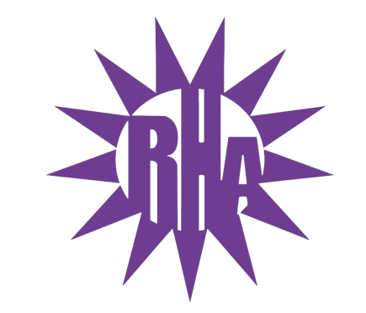
Residence Hall Association
General Assembly Meeting
October 26, 2022
UC 275
- Call to Order
- Benson/Clem Hall Highlight!!!
  - Reps talked about Halloween Bag decorating, caramel apple, making and door decorating with Ras for their October programs. Future Programs include a paper airplane contest in November, and a gingerbread cookie decorating program and ugly sweater contest in December.
- Lee/Bigelow Hall Highlight!!!
  - Reps talked about Switching it up with Lit program, Pie an RA- Resulted in $90 to the Warhawk food pantry, Jitters Takeover.
- Approval of Minutes
  - October 12, 2022
  - Any Edits: rhapresident@uww.edu
- LIT Reports
  - https://tinyurl.com/RHAreport
- Executive Reports
- Advisor Reports
- Old Business
- New Business
  - RHA Executive Board Induction
    - Orin and Chiara
  - RA Informational Session Presentation
  - Spaghetti Painting Party!!!
    - Right After GA Meeting
    - FREE FOOD!!!!!!!!!!

- Committee Report
  - UW-W Homecoming Committee
    - Congratulations Erin for being in the Top 5 for Homecoming Court!!!
    - Congratulations Orin for being in the Top 15 for Homecoming Court!!!
    - Events Still to Come
      - Talent Show: Thursday, October 27th at 7pm in Young Auditorium
        - FREE with your HawkCard!!!
        - Ushers needed!!!
      - Indoor Games: Friday, October 28th at 12pm in Kachel Fieldhouse
      - Parade: Saturday, October 29th at 10am on Main Street
        - Arrival Time for Check-In: 8:45AM
        - Be at Lot 2 at 8:30AM
  - UC Advisory Board
  - UW-W Dining Advisory Board

- Program Updates
  - Whitewater’s Got Talent – November 29th
    - Audition Dates
      - Sunday, November 6th from 4-6pm at Jitters
      - Monday, November 7th from 4-6pm at Jitters
      - Thursday, November 10th from 4-6pm at Jitters
    - ACD/CD and Student Judges Discussion
- WSG Report
- NRHH Report
- Jitters Report
- RA Report
- Final Thoughts
  - Painting Party Reminder!!!
  - Snaps
  - U Rock U Rule
    - https://tinyurl.com/RHArockrule
  - Golden Artichoke
- Adjournment / Walk over to Ma’iingan

Next Meeting: November 2, 2022 in UC 275
Next Hall Highlight: Wells
Theme: Fantastic Flannels

