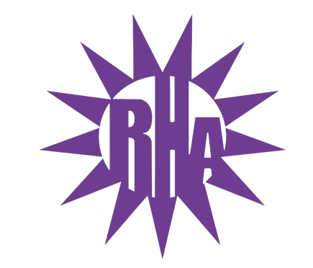
Residence Hall Association
General Assembly Meeting
November 2, 2022
UC 275
- Call to Order
- Wells Hall Highlight!!!
- Approval of Minutes
  - Any Edits: rhapresident@uww.edu
- LIT Reports
  - https://tinyurl.com/RHAreport

- Executive and Advisor Reports
- New Business
  - UW-W Dining Introduction
  - Residence Comments and Concerns Forum
    - This will be a monthly tradition in which students bring concerns to the meeting to be addressed
  - Whitewater’s Got Talent ACD/CD and Student Judges Decision
    - Jacob Nicolosi and Genna Robinson were chosen, and last year’s judges were informed that they would have a different job this year should they be willing to participate.
- Committee Report
  - UW-W Homecoming Rewind Recap
    - Homecoming went really well, we won 1st place for large organization in Parade and we believe we won 3rd in Trivia.
  - Programming Committee Interest
    - Inform Orin should you wish to be involved with Programming Committee
- Program Updates
  - Whitewater’s Got Talent – November 29th
    - Audition Dates
      - Sunday, November 6th from 4-6pm at Jitters
      - Monday, November 7th from 4-6pm at Jitters
      - Thursday, November 10th from 4-6pm at Jitters
- WSG Report
- NRHH Report
- Jitters Report
- RA Report
- Final Thoughts
  - Snaps
  - U Rock U Rule
    - https://tinyurl.com/UrockUruleRHA
  - Golden Artichoke
- Adjournment

Next Meeting: November 9, 2022 in Baker/Tilly Lecture Hall (HH2203)
Next Hall Highlight: Tutt/Fischer Theme: Pajamas

