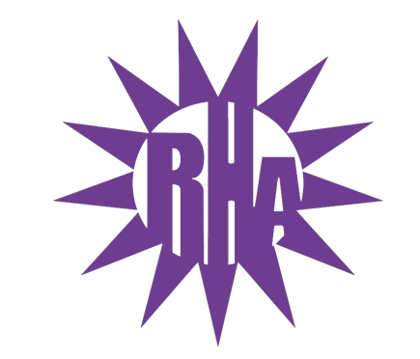
Residence Hall Association
General Assembly Meeting
November 30, 2022
Baker/Tilly Lecture Hall in Hyland Hall (HH2203)
- Call to Order (7:03)
  - Quorum met – 11 (10 LIT reps and 1 NRHH)
- Approval of Minutes
  - October 26, 2022
  - November 2, 2022
  - November 11, 2022
  - November 16, 2022
  - Any Edits: rhapresident@uww.edu
- Old Business
  - Residents Comments and Concerns Forum Reminder and Topic Discussion
  - Budgeting Basics Refresher by Vice President Erin Bleicher
- New Business
  - ISA Funding Request: Annual International Dinner
    - 42nd Annual International Dinner
      - Dinner on March 10th
    - Target for March 2023 is 250 (Last year was 200)
    - This year’s request: $1000
    - Last year’s request: $750, approved $750
    - Vote for funding approval next RHA meeting 12/7
    - Asking SUFAC, WSG Housing, RHA
      - Emails out to chancellor, provost, deans for money
      - Terry T often buys some to give away
    - Funding is to help reduce cost
      - Tickets typically $10, want to get it to $5 per student and $10 for guests
  - Constitution Amendment Proposal by Vice President Erin Bleicher
    - Changing election process to an interview process
    - Gallery Comment
      - Liked that it reflected a job interview instead of being voted in since they are paid
    - Gallery Question
      - Would there be an opportunity to increase size of selection committee if more student body wanted to join?
      - Erin: At this time, this is a baseline to get the process going and if more individuals show interest, then we will adjust to get others the opportunity.
    - Vote to combine all amendments – 10-0-0
    - Vote passes for constitutional change – 10-0-0
- Committee Report
  - Programming Committee: No meeting December 2nd
    - Please consider being a part of Programming Committee next semester
- Program Updates
  - Thank you for everyone for coming to Whitewater’s Got Talent
    - Over 160 people in attendance
    - Thought we would have to decrease the number of seats for next year
- Pulliam Hall Highlight!!!
  - Most Recent Event: Game Night – Minute to Win It on November 21at @ 8:30pm
  - Upcoming Events
    - Jitters Takeover (Collab w/ Ma’iingan)
      - Wednesday December 7th @ 8pm
    - Pulliam All-Hall Meeting w/ Cookies and Cocoa
      - Thursday December 8th @ 6:15pm
  - Icebreaker: Zip-Zap-Zop
- LIT Reports
  - https://tinyurl.com/RHAreport
- Executive Reports
- Advisor Reports
- WSG Report
  - WSG Listening Forum December 1, 2022 @ 6:30pm in UC Old Main Ballroom
  - WSG Dining Forum December 5, 2022 @ 5pm in UC Hamilton Room
- NRHH Report
- Jitters Report
- RA Report
- Final Thoughts
  - Snaps
  - U Rock U Rule
    - https://tinyurl.com/UrockUruleRHA
  - Golden Artichoke
- Vice President Announcement
  - Erin’s Last Meeting is December 7th
- Adjournment (8:14)
Final Meeting of the Semester: December 7, 2022 in UC275
Next Hall Highlight: Arey/Fricker Theme: Holiday Wear/Ugly Sweater

