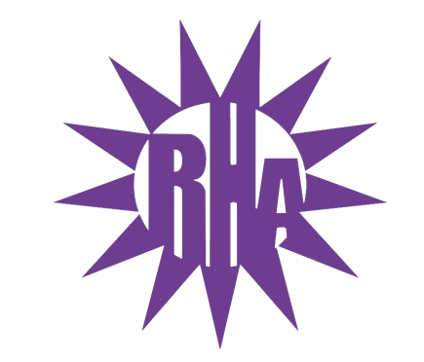
Residence Hall Association
General Assembly Meeting
March 22nd, 2023
UC 275
- Call to Order (President Isabel) (7:05)
- Approval of Minutes (Executive Assistant Jay)
  - March 15th
  - Any Edits: rha@uww.edu
- Icebreaker: Whose Crocs Are These??? (President Isabel)
- Old Business
- New Business
- Committee Report
- Program Updates
  - Spring Canvas Painting (Co-Programmer Ryan)
    - April 7th in Jitters from 7-9pm
    - Paint supplies provided
    - Spring themed
  - Summer Camp/Menstrual Mail (NCC/Co-Programmer Orin)
    - April 3rd 5pm in UC Hamilton room
    - Need more volunteers
    - Accepting donations of menstrual products at entrance
    - People who donate will get entered to win a prize
  - RHA Carnival (Vice President Julihannah/President Isabel)
    - All LITs showed interest in RHA carnival
    - Sheet to sign up for booth
    - May 5th tentative date
- Comments and Concerns Forum
This semester, we will be having a place on the agenda where anyone can share a comment or concern with RHA. If the comment or concern cannot be answered at this time, we will table the discussion for next week’s meeting and will have a place holder for the topic in the agenda. Please keep the presentation to around three (3) minutes so we can have time for as many individuals as we can. Thanks!
- LIT Reports
  - https://tinyurl.com/RHAreport
  - Arey/Fricker
    - Lucky bingo event last Thursday
    - Jitters takeover yesterday
    - Earth day program in the works
  - Bigelow/Lee
    - Last Wednesday was Jitters takeover
  - Ma’iingan
    - Bingo night last Wednesday
    - Will be changing LIT logo
    - Welcome back after spring break for residents
  - Wells
    - Trash for Cash event earlier today
    - Penny Wars starting after break
    - Blankets for Cerebral Palsy event with NRHH coming up
  - Wellers/Knilans
    - Jitters takeover tomorrow murder mystery
- Executive Reports
  - NACURH (NCC/Co-Programmer Orin)
    - National leadership conference
    - May 26-28 Ball State Indiana
    - Sign up closes Friday at 11:59pm
  - U-Dub-Duck
    - Duck has been returned
    - Duck will go to Clem/Benson after break
  - TikTok (PRD Julissa)
    - Follow RHA TikTok page
    - Starting soft skills campaign
- Advisor Reports (Advisor Travis)
  - Benson/Clem is setting up for jitters takeover tonight
  - Had a door dec making event
- WSG Report (Sen. Doug A. Bradley)
  - Held annual debate
  - Encourage you to vote April 11-12
  - April 10th heading to rock county campus
- Bobbie’s Report (NRHH and Jitters)
  - NRHH
    - Blood Drive tomorrow from 12-6pm
    - Wells LIT Collab Tomorrow from 4-7 pm
    - Menstrual mail collab- April 3rd
  - Jitters
    - Drinks of the Month
      - Raspberry Blossom White Chocolate Macchiato
      - Hoppin/Hatchin into spring
        - Brownie mix shake topped with whip and green sprinkles and a peep
    - Starting April 9th opens for e-Board elections
    - Programs
      - Clem/Benson Takeover tonight!
      - Wellers/Knilans LIT takeover tomorrow!
    - We are closed over spring break until April 3rd
- RA Report
- Final Thoughts
  - Reception of excellence nominations are due Friday at midnight
  - Vote on April 4th for state supreme court elections and local schoolboard elections
  - Nominate staff for awards
    - Check quarantine folders for email to submit nominations
  - Next meeting is Kayla Day
    - Her birthday is April 1st so April 5th theme will be dress up like Kayla day
  - RA selections will be announced tomorrow
    - You will know which building
  - Snaps ( Co-Programmer Ryan)
  - RHA Rockstars (PRD Julissa)
    - https://tinyurl.com/UrockUruleRHA
    - Ryan Rubick
    - Mitch Roe
  - Golden Artichoke (Executive Assistant Jay)
    - Wells LIT
- Adjournment (President Isabel)(8:03)
Next Meeting: April 5th, 2023 in UC 275 Theme: Kayla Day

